39.66: a) 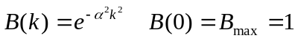
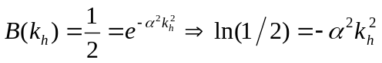
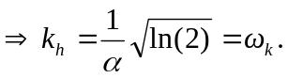
Using tables: (b) 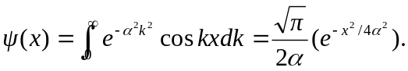
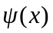 is a maximum when x = 0.
c) 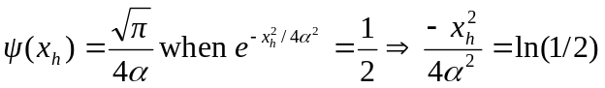
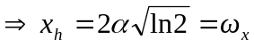
d) 